**computerdevelopmentoverview**

**Computer Development Overview**

**A Data Communication Historical Series**

**By Bob Pollard**

**A brief pictorial summary of Computer Development involving Relays to Integrated Circuits**

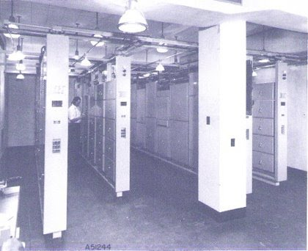

**Bell Relay Computer racks containing the computing, storing and controlling relays (1940s)**

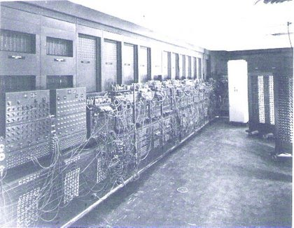

**ENIAC (Electronic Numerical Integrator and Computer); the world's first electronic digital computer utilizing approximately 20,000 vacuum tubes and core memory (1946)**

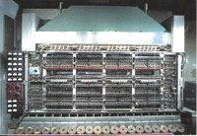

**The IAS Computer, 1952 (Smithsonian photo)**

The IAS Computer was named for the Institute for Advanced Study: It cost several hundred thousand dollars to design and manufacture. The goal of developing the IAS was to make digital computer designs more practical and efficient. The development project began in 1946 and the computer was ready for use in 1952.

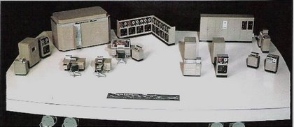

**A Model of the UNIVAC I, 1954 (Smithsonian photo)**

The UNIVAC (Electrical Numerical Integrator and Computer), like the ENIAC, had vacuum tube circuit elements and, in addition, approximately 18,000 crystal diodes. Central memory was handled using acoustic delay-line tanks. UNIVAC also had an external magnetic tape memory, as well as magnetic tapes used for input and output.

Equipment included: A Uni-printer (2 parts), a tape to card converter (3 parts), a high-speed printer (4 parts), 8 Uniservo tape drives (L-shaped), supervisory control / typewriter (2 parts), Unityper II, verifier, Central Processing Unit (CPU), and a card to tape converter (3 parts).

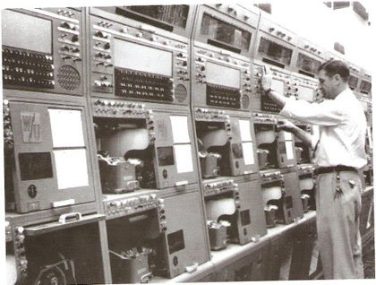

**Plan 55 automatic paper tape switching center receiving aisle: 1957 through early 1960s; used vacuum tubes, relays and mechanical components**

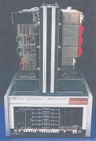

**PDP-8**

In 1959 the Digital Equipment Corporation (DEC) was well established and introduced its first computer, the PDP-1 (Programmed Data Processor).

About 50 were produced; priced at $120,000. The PDP-1 was followed by a series of other more powerful, but less expensive products in the PDP line.   
  
The PDP-8 was introduced in 1965 and the first model sold for $18,000. Ultimately over 50,000 PDP-8's were sold. The PDP was considered a mini-computer because of its small size. The computer equipment pictured above would fit in one equipment rack.

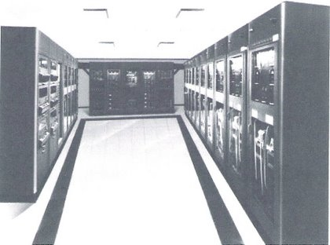

**Typical Computer Main Frame (1960s)**

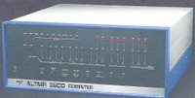

**Altair Computer, 1975**

Using the Intel 8080 chip, MITS (Micro Instrumentation and Telemetry Systems) offered a computer kit called the Altair: a small personal computer; cost: kit; $395; assembled:$498.

It had little internal and no external memory, no printer, and no keyboard or other input device. An Altair fitted out with those items might cost $4000; the equivalent to the cheapest PDP-8 minicomputer, a reliable and established performer. Most purchasers found the kit difficult to assemble. And it was sometimes difficult to get the Altair to operate reliably.

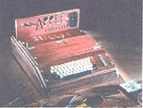

A 1976 Apple I Computer, a kit computer. Users bought the kit and built their own case.

**Smithsonian photo**

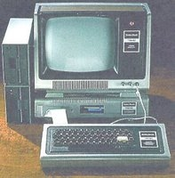

**Smithsonian photo**

Radio Shack introduced the TRS-80 (right) in 1977 at a base price of only $400. The base model had only 4K bytes of memory and could not handle lowercase letters. One could expand its storage and input/output by purchasing an Expansion Interface at additional cost. The company soon introduced advanced models with more internal memory and disk drives instead of cassettes for entering programs.